IEC FOOD SAFE MOTORS

ABB has launched a full range of IEC Food Safe motors designed for applications in the food and beverage industry that need frequent sanitation. The new IEC Food Safe motors are part of ABB’s Food Safe family that includes stainless steel NEMA motors, mounted ball bearings and gearing.

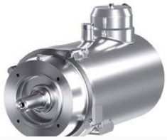

ABB Ability Smart Sensor - Motores

ABB ha desarrollado un sensor compacto que está unido al bastidor de motores de inducción de bajo voltaje. No es necesario ningún cableado. El uso de algoritmos de a bordo, basados en décadas de experiencia en motores de ABB, permite al pequeño sensor inteligente informarnos sobre el estado del motor a través de un teléfono móvil y a través de internet a un servidor seguro. Esta solución puede hacer que un gran número de motores se puedan beneficiar de estos dispositivos inteligentes.

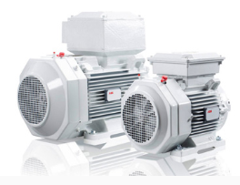

IE3 MOTORS

ABB, the leading power and automation technology group, is expanding its range of low voltage cast iron IE3 motors for explosive atmospheres with the introduction of new mid-range products.

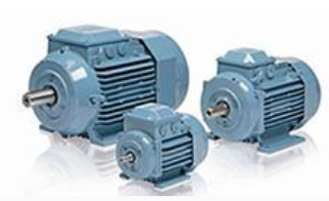

# High-voltage surge arresters

ABB surge arresters are the primary protection against atmospheric and switching over voltages. ABB offers a complete range of surge arresters for high voltage applications comprising of solutions for AC and DC up to 1,100kV as well as special applications. The portfolio includes porcelain housed, silicone housed or SF6-insulated high voltage arresters. ABB has more than 75 years of experience of overvoltage protection and more than 25 years of experience with silicone insulation. The arresters are installed all over the world in all type of climates. The designs are type tested according to the IEC 60099-4 , ANSI/IEEEC62.11 and also comply with customer specific standards.

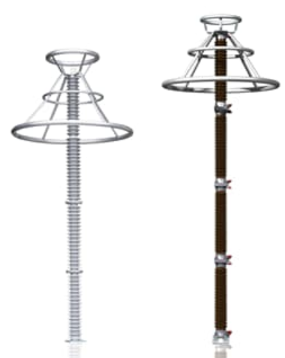

# High-voltage surge arresters II

Surge arresters are used for protection of electrical equipment from all kind of overvoltages caused by lightening or switching operations. ABB has more than 100 years of experience in designing and manufacturing surge arresters and protection devices.

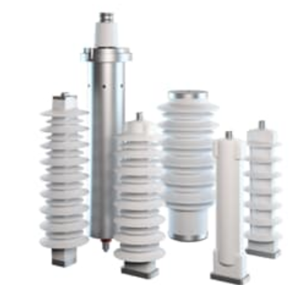

# Small distribution transformers

Small distribution transformers are typically oil-immersed and suitable for pole-, pad- or ground-mounting. They represent an economical option for certain networks, particularly those with low population densities.

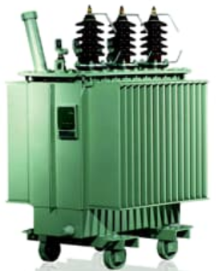

# Medium distribution transformers

Medium distribution transformers are used to step down three-phase high voltage to low voltage for energy distribution, mainly in the countryside or low-density populated areas.

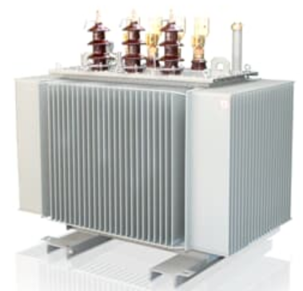

# Fit for purpose distribution transformers

# Distribution transformers are critical equipment for renewables and ABB has the world’s largest installed base of transformers providing more renewable energy than any other supplier. “Fit for purpose” distribution transformers offer application-specific units that have different design features compared to standard distribution transformers.

# 